Form 1572 FDA - Completion Guide
Definition: The Statement of Investigator (Form 1572 FDA) is a document signed by the Principal Investigator that provides required investigator information to the sponsor and affirms the PI’s commitment to comply with applicable FDA regulations governing the conduct of a clinical investigation involving an investigational drug or biologics.
By signing Form 1572, the Principal Investigator (PI) agrees to:

- Conduct the study according to the protocol and FDA regulations.
- Personally, supervise or appropriately delegate study-related activities.
- Ensure informed consent is obtained from all participants.
- Report adverse events and maintain accurate study records.
- Allow FDA and sponsor representatives to inspect study records.
      - Ensure the study is reviewed and approved by an Institutional Review Board (IRB) or Ethics Committee(s).

The form also documents:
- Study site locations
- Sub-investigators involved in the trial
- Research facilities used
- Independent Review Board (IRB) information

Purpose: The purpose of this document is to provide practical guidance on how to complete Form FDA 1572. This guidance applies to U.S.-based Principal Investigators. This document is intended to supplement, not replace, FDA guidance, include the FDA information sheet titled “Instructions for Filling out Form FDA 1572 Statement of Investigators - Statement-of-Investigator-(Title-21--Code-of-Federal-Regulations-(CFR)-Part-312)-(Guidance) (4).pdf
Investigators and teams should always ensure they are using the most current version of Form 1572, which is available on the FDA website - FDA-1572_Form_secured_04-13-2025
Intended Audience: Clinical Research Coordinators, Supervisors and Regulatory Staff
Applies to: FDA-regulated IND drug and biological studies. An FDA 1572 Form is not required for non-FDA regulated studies (including phase 4 IND exempted studies), observational studies without an IND and behavioral or social science studies.
Timing of Completion: The FDA 1572 Form must be completed and fully executed during study start-up and prior to the initiation of any drug trial (FDA-regulated or biologic clinical trial conducted under an IND).
Roles and Responsibilities:
- The Clinical Research Coordinator (CRC) typically prepares the draft Form FDA 1572.
- The sponsor/CRO provides pre-populated study, vendor and laboratory information.
- The Principal Investigator is responsible for: reviewing, confirming accuracy, and signing the final form.

In summary, Form 1572 serves as the investigator’s formal commitment to comply with FDA requirements and conduct the study responsibly.

This form will be completed in collaboration with the CRO/Sponsor and the CRC. The original copy will be retained at the site and filed in the regulatory binder. A copy is required to be provided to the CRO/Sponsor.
Step-by-Step Guide:
- Request a partially filled 1572 from the CRO/Sponsor
  - They will complete the vendor information and addresses (they have this information, and are required to provide it).
  - If a new Form 1572 FDA is required you can obtain the most updated version from FDA-1572_Form_secured_04-13-2025.
    - If you initiate the 1572, it must be sent to sponsor to input the central vendor information PRIOR to signature.
- Section 1- Principal Investigator’s legal name and address
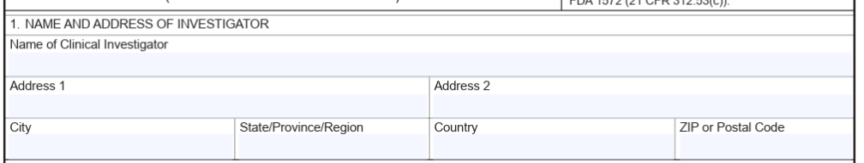
  - Complete the PIs name and full work address where PI can be reached by mail.
  - The PI address should match the address listed on the PI’s CV.

- Section 2 – Education and training documentation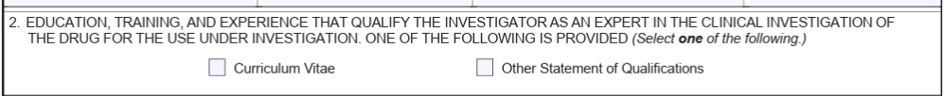
  - Select CV as this is what is most commonly used to provide proof of education and training.
- Section 3- Address of school, hospital…. The name and address of all locations are routinely used to conduct the clinical investigation. 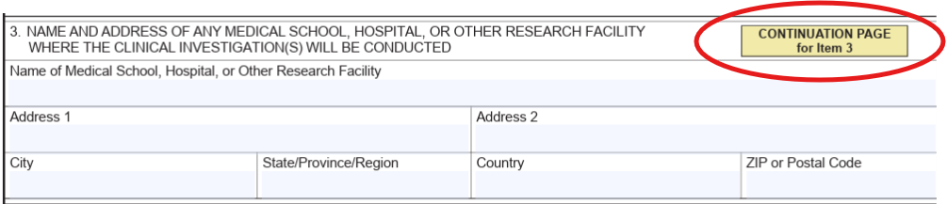
  - Locations where subjects will be seen for study-related procedures (including consent randomization and all study visits if different than primary location).
  - Location(s) where clinical data will be generated or collected.
  - Locations where the test article will be shipped, prepared and/or stored.
  - This should encompass the following, but is not limited to the items below. You will need to determine according to the study which locations will be used.
    - The drug shipment address must also be listed separately in this box, if it differs from the site locations(s) already entered.
    - ACTRI/ Level 1, Level 2 and Rady’s Children Hospital
    - Pharmacy
    - MRI Center
    - Hospital
Please note the following when completing the 1572 form as applicable:
Satellite Site: A secondary location where subjects are seen under the supervision of the primary site.
Additional Facility: A location where participants are not treated, but where study-related procedures or testing are performed (e.g. PET Scan, Local Labs).
  - What is NOT needed in section 3
    - If the protocol specifies that the investigative product can be administered at a subject’s home (for example, the protocol allows for daily injections to be administered by a registered nurse in the subject’s home), the subjects’ home addresses do not have to be listed on the Form FDA 1572. Study records should reflect that the test article was administered at subjects’ homes per the protocol.
  - If you need an additional page with more entry space for additional entries select the continuation page.
- Section 4 - Name and addresses of central and/or clinical laboratory facilities that will be used in the study 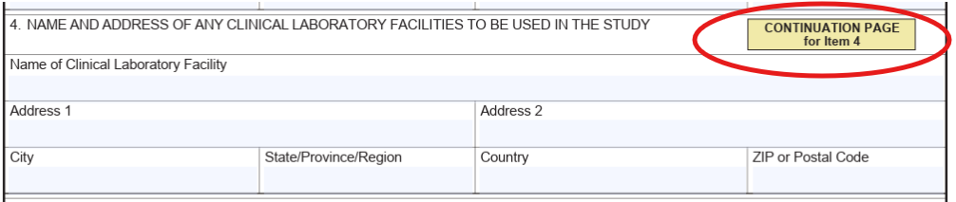
  - If both central and local labs are to be used, both must be included.
  - Identify clinical laboratories or testing facilities directly contributing to or supporting the clinical study (for example, diagnostic labs performing blood work, central and local imaging centers, central and local ECG reading centers and cardiology lab and local labs performing blood work, ophthalmology facilities etc.). This may include analytical labs that provide pharmacokinetic analysis, and laboratories supplying efficacy data for clinical investigations conducted under an Investigational New Drug Application (IND).
  - If a laboratory is sending samples to satellite or other contract labs for additional testing, it is only necessary to list the primary laboratory, provided that laboratory can trace the samples to each of the satellite and/or contract labs where the tests were performed.
  - The Sponsor will need to provide you with the Central Laboratory information.
  - If you need an additional page with more entry space for additional entries select the continuation page.
- Section 5- Name and address of the Institutional Review Board (IRB) or Ethics Committee(s)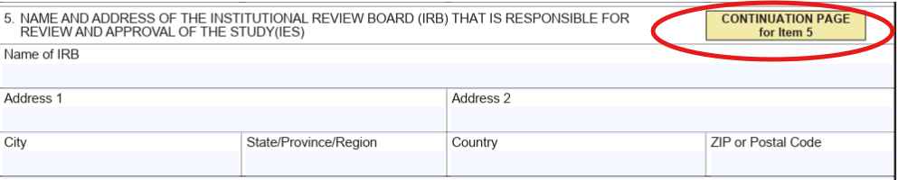
  - The full name and address of the Independent Review Board (IRB) or Ethics Committee(s) responsible for the review and approval of the study
    - If you are using a central IRB, ONLY the central IRB should be listed. Kuali should not be added as they are not responsible for the review and approval.
- Section 6: Names of Sub-Investigators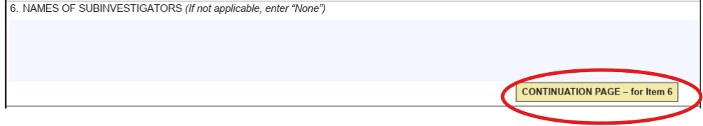
  - Requires the investigator to provide a list of sub-investigators (e.g., research fellows, residents) who will assist in the conduct of the clinical investigation.
  - The purpose of Field 6 is to capture information on individuals who make a significant contribution to the conduct of the study, including but not limited to the following:
    - Any individual assisting the Principal Investigator in the conduct of the investigation and making a direct and significant contribution to the data.
    - Making decisions about patient care
    - Anyone who forms medical opinions about eligibility, diagnosis, treatment or the clinical status of the patients in a study
    - PI should not be listed in this section as she/he is already listed in Box 1.
    - Anyone listed in this section must also sign a Financial Disclosure Form and submit a CV and Medical License or another applicable licensure.
Note: Some sponsors restrict inclusion on the FDA to clinical staff only. The sponsor will specify whether Clinical Research Coordinators (CRCs) should be listed on the 1572.
  - You will want to confirm with the PI who the sub-investigators will be.
  - If you need an additional page with more entry space for additional entries select the continuation page.
Section 7- Protocol name and code number (IND number will be added when available)
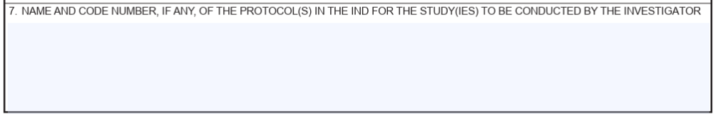
  - This box is typically pre-populated by the sponsor.
  - Or, you may obtain this information from the master protocol.
- Section 8- Protocol Information
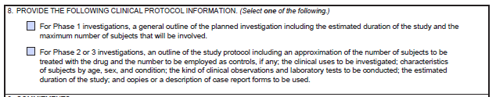
  - Only one box may be selected.
  - For a combined Phase 1/2 investigation, check only the second box.
  - For a Phase 4 post-marketing clinical trial, check only the second box, and state in Field 7 that the study is a Phase 4 study.
- Section 9- Commitments 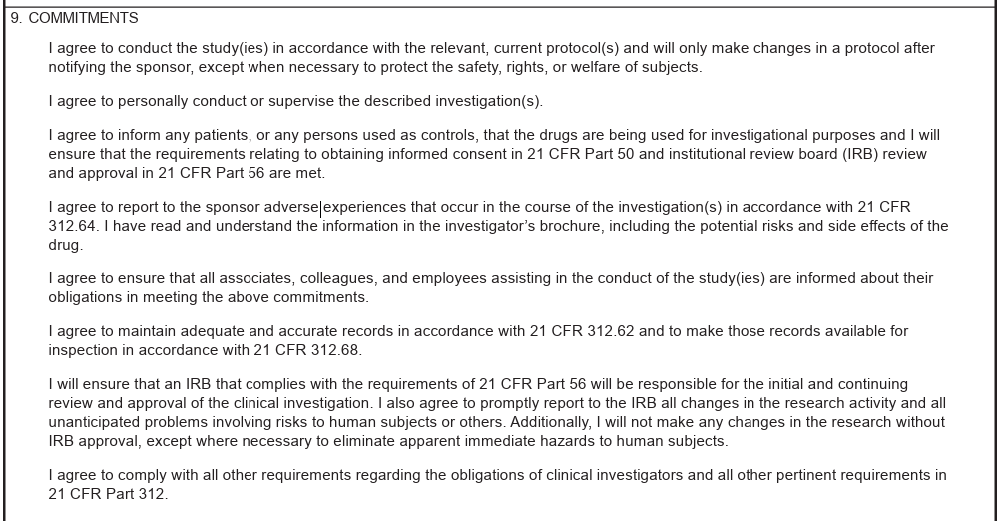
  - Contains important commitments that the investigator agrees to by signing the form.
- Section 10 and 11 must include the Investigator Signature and Date 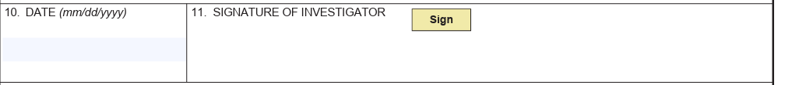
- Section 10 and 11 must be signed by the PI (either by hand or using a validated electronic method). If signed by hand, the signature date must also be hand-written and should be in MM/DD/YYYY format (as indicated in the 1572 form date section).
- The PI signature cannot be delegated under any circumstances.

Reminders
Updated FDA 1572 Form should be completed and submitted to the sponsor promptly following any applicable change and prior to implementation when possible, including but not limited to:
- Addition, modification or removal of a study-related address (lab, clinic)
- Addition or removal of a sub-investigator
- Change in Principal Investigator (PI)
Common local Addresses
  - Jennifer Graves MD, PhD, MAS
9452 Medical Center Dr. Suite 4W-222
La Jolla, CA 92037
  - Altman Clinical and Translational Research Institute Pharmacy
9452 Medical Center Dr., Suite 1East 312
La Jolla, CA 92037
  - University of California San Diego Office of IRB Administration
9500 Gilman Dr.
La Jolla, CA 92093
  - Altman Clinical and Translational Institute, University of California San Diego
9452 Medical Center Dr., Suite 1E 402
La Jolla, CA 92037
  - UC San Diego Health Center for Advanced Laboratory Medicine (CALM)
10300 Campus Point Dr. Suite 150
San Diego, CA 92121
  - Center for Translational Imaging and Precision Medicine, UCSD ACTRI
9452 Medical Center Dr., Suite L3601
La Jolla, CA 92037
  - UC San Diego Health ECOB
9444 Medical Center Dr., 1st Floor
La Jolla, CA 92037

